A DARK AND STORMY NIGHT

They were together in the House.

Just the two of them.

It was a cold, dark, stormy night. The storm had come quickly.

Each time the thunder boomed he watched her jump.

She looked across the room and admired his strong appearance...and wished that he would take her in his arms, comfort her and protect her from the storm.

Suddenly, with a pop, the power went out... She screamed...

He raced to the sofa where she was cowering.
He didn't hesitate to pull her into his arms.
He knew this was a forbidden union and
expected her to pull back.

He was surprised when she didn't resist but instead clung to him.

The storm raged on...

They knew it was wrong...

Their families would never understand. So consumed were they in their fear that they heard no opening of doors...

Just the faint click of a camera......

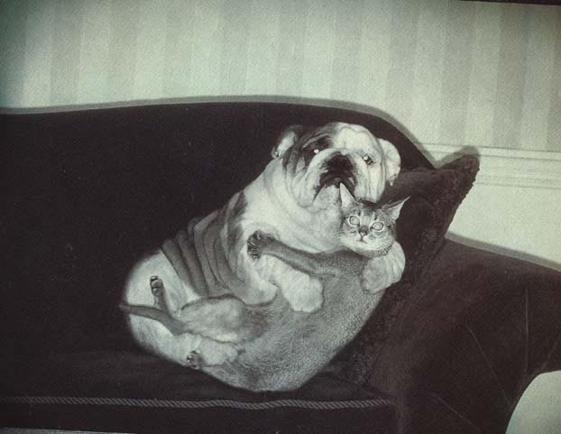
Have you smiled today?

